Resume
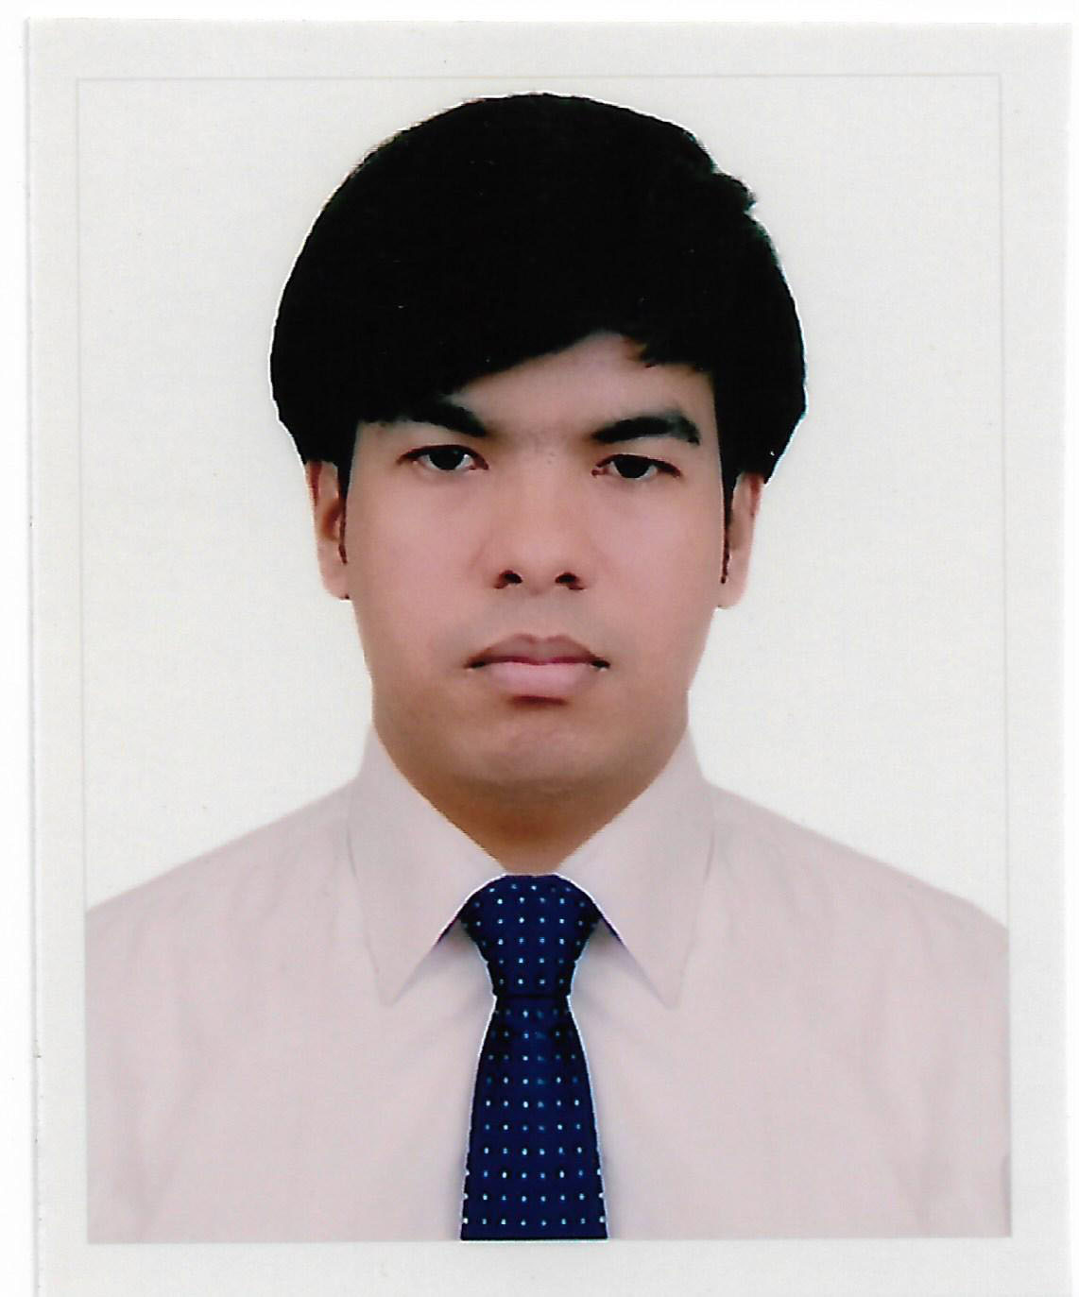
of
Md. Nazmul Hasan
Lake view Plaza, Taltola, Agargaon, Dhaka-1207
Phone: +8801965331603,+8801725208161
Email: nazmulhasasn3@gmail.com

Objective
To have a respective and challenging career where my skills will be utilized to their full potential as well as to build an excellent profession by utilizing my qualification and experience.

Career Summary
Would like to Work with efficiency in different sectors of business management which includes customer Relations, salesmanship, Administration, customer service, Stock management, and inventory management abilities.

Special Qualification
Have excellent communicative skills to build professional relationships with people of multiple personalities. Flexible, dependable and able to work under pressure under tight deadlines.

Employment History

- Organization Name : Ryans Computers Limited.
Department : Warranty
Designation : Sr. Executive
Duration : 01 January 2015 to Still now.
Place : Dhaka.

- Organization Name : Souvenir Group Ltd.
Designation : Sr. Executive
Duration : 1st January 2014 to 1st December 2014.
Place : Dhaka.

- Organization Name : Human resource management (Lovious)
Designation : Field Assistant
Duration : 1st March 2013 to 1st September 2013.
Place : Dhaka.

Educational Qualification

Masters of Social Science (M.S.S)
▪ University : Under Dhaka University
▪ Name of Institute : Govt. Titumir College, Dhaka.
▪ Subject : Sociology.
▪ Year of Passing : 2014
▪ Result GPA : 2.61

Bachelor of Social Science (B.S.S)
▪ University : National University, Gazipur.
▪ Name of Institute : Govt. Titumir College, Dhaka.
▪ Subject : Sociology.
▪ Year of Passing : 2013
▪ Result GPA : 2.82
Higher Secondary Certificate (H.S.C):
▪ Name of Institute : Govt. Shah Sultan College, Bogura.
▪ Board : Rajshahi
▪ Group : Humanities
▪ Passing Year : 2009
▪ Result (GPA) : 3.70

Secondary School Certificate (SSC)
▪ Name of Institute : Madhai Nagar B-L High School

▪ Board : Rajshahi
▪ Group : Humanities
▪ Passing Year : 2007
▪ Result (GPA) : 3.06

Interest
- Traveling, Reading, Net Surfing, Watching Movies, Photography.

Language Proficiency
- Bangla and English: (Listening, Speaking, Reading & Writing).

Skills
- Quick Learner, Hard Worker, Creative and Confidential.
- Good on Presentation, Motivation.

Computer Skills

- Expert user of Microsoft word & Microsoft excel.
- Have depth knowledge Internet browsing and e-mail applications.
- Have little bit knowledge adobe Photoshop.
- Have intermediate knowledge in computer hardware.

Personal Profile
Father’s Name : Md. Abdur Razzak
Mother’s Name : Kolpona Begum.
Date of Birth : 24th Octobor , 1991
Nationality : Bangladeshi by birth.
Religion : Muslim.
Marital Status : Single.
Permanent Adress : Vill: Amshara, P/O: Amshara, P/S: Salanga,
Dist: Sirajganj.
Height : 5’-8”
Weight : 75 k.g.

Reference
Md. Abul Bashar  Work Assistant (LGED)  Moholchari, Khagrachari,  Mobile No: 01713797574 | Md. Bokul Islam  Sr. Sales Representative  Sherpur,Bogura  Deep-Laid Pharmaco,Bangladesh  Phone No : 01770114024
Declaration of Authenticity:
I am declaring that the information which I have presented is true to my knowledge & I will be able to present appropriate if is required.

Signature Date: 21-05-2020


Nazmul

